JOURNAL OF ENGINEERING SCIENCES  Volume 9, Issue 1 (2022)  Author1, F. A., Author2, S. B., Author3, T. C. (2022). Article title. Journal of Engineering Sciences, Vol. 9(1), pp. E1-E5, doi: 10.21272/jes.2022.9(1).e1 | 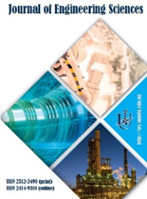
Article Title
Author1 F. A.^{1[0000-0000-0000-0000]}, Author2 S. B.^{1*[1111-1111-1111-1111]}, Author3 T. C.^{2[3333-3333-3333-3333]}
¹ The Organization1, Full postal address, Postal code, City, Country;
² The Organization2, Full postal address, Postal code, City, Country
Article info:  Submitted:  Accepted for publication:  Available online: |  | *Corresponding email:  address@gmail.com
Abstract. The abstract should summarize the contents of the paper in short terms. Abstract obligatory should contain 150–250 words.
Keywords: please indicate about 5 keywords separated by a comma. Keywords should not repeat phrases from the title of an article.
- Introduction
A text of an Introduction…
- Literature Review
A text of a Literature Review…
- Research Methodology
  - Sample of the 1st-level heading
Only two levels of headings should be used. Lower level headings remain unnumbered.

3rd-level heading 3.
A text of the 3rd-level heading.
  - Sample of the 2nd-level heading
The following Table 1 gives a summary of all heading levels.
Table 1 – Table captions should be placed above the tables
Heading level | Example | Font size and style
Title (centered) | Paper title | 12 points, bold
1st-level heading | 1 Heading 1 | 11 points, bold
2nd-level heading | 2.1 Heading 2 | 10 points, bold
3rd-level heading | Heading 3 | 10 points, bold
A text after Table…
- Results
Displayed equations are centered and set on a separate line:
$a^{2}+b^{2}=c^{2}.$ (1)
Please try to avoid rasterized images for line-art diagrams and schemas. Whenever possible, use vector graphics instead (Fig. 1).
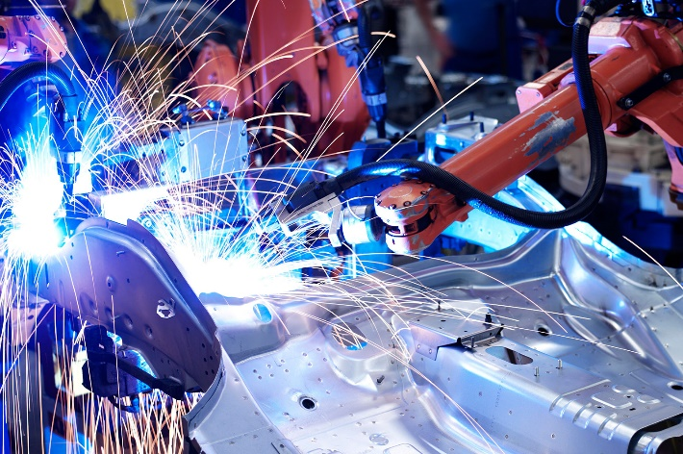
Figure 1 – A figure caption is always placed below the illustration and centered
The width of the figures placed in a single column should be less than 82 mm.
Figures with a width of more than 82 mm should be centered on the entire page. However, the width should be less than 170 mm.
- Discussion
A text of a Discussion…
- Conclusions
A text of Conclusions…
The paper should include the following sections: Introduction, Literature Review, Research Methodology, Results, Discussion, Conclusions, Acknowledgments (optional), and References.
- Acknowledgments
A text of Acknowledgments…
In References, all the citations should be in English. The total number of references should be more than 15.
The total number of citations on publications from the databases Scopus and Web of Science Core Collection should be more than 80 %. Self-citations should not exceed 20 %.
For citations, it is needed the use of square brackets with numbers. The following bibliography provides a sample reference list with entries for articles [1], books [2], and proceedings [3] according to the APA standard. The use of DOI (Digital Object Identifier) at the end of citations is preferable.

References
- Author1, F. A., Author2, S. B., Author3, T. C. (2020). Article title. Journal Title, Vol. 7(1), pp. E1-E5, doi: 10.21272/jes.2020.7(1).e1.
- Author1, F. A., Author2, S. B. (2016). Book Title (2nd ed.). Publisher, City, Country.
- Author1, F., Author2, S. (2020). Title of a proceedings paper. Conference Title. Publisher, City, Country, Vol. 1(4), pp. 26-35.

